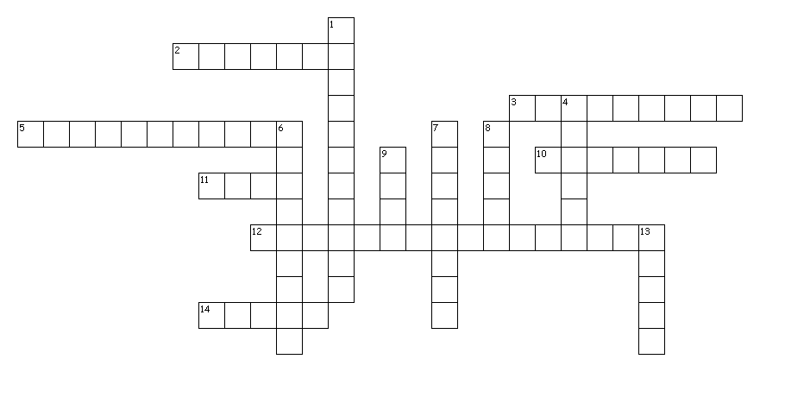
Across
2. Defeated the Incas, opening South America to Spanish rule.
3. Greatest Inca leader. Name means "Earthshaker." Known for uniting the Inca Empire.
5. Area including much of today's Mexico and parts of Central America. "Meso" is Latin for "Middle."
10. Being dishonest, or disloyal to one's government.
11. Group of people who formed a civilization in the Yucatan Peninsula of Mexico and stretched into Central America.
12. Southeast piece of land in present day Mexico surrounded by water on three sides (Gulf of Mexico and Caribbean Sea).
14. Incas used this knotted rope to represent numbers or keeping records.

Down
1. The Aztec emperor that was in control when the Spanish took over the Aztecs.
4. Conquered the Aztecs allowing Spanish Rule to spread in Central America.
6. Inca emperor that Pizarro tricked for power and later was sentenced to death by Pizarro.
7. The sole right to sell or trade an item.
8. Mayan for "Flat Region." Located in present day Guatemala and had heavy dense forest. Settlement for the Mayan Civilization.
9. Empire created in the Andes Mountains and started in present day Peru. Largest empire in the Americas and founded in 1100 AD.
13. Warlike nomads living in Mexico starting in 1250 AD. Quickly built an empire in present day Mexico.
14 of 14 words were placed into the puzzle.
Created by Puzzlemaker at DiscoveryEducation.com

