The Early Americas Mapping
Directions: Draw/Label the following bodies of water, landforms/rivers, and countries on the map on the back of this page. Use the maps on R2 – R15, 575, 577.
Bodies of water/Rivers | Landforms | Countries
- Lake Titicaca  - Pacific Ocean  - Atlantic Ocean  - Gulf of Mexico  - Amazon River  - Lake Texcoco  - Strait of Magellan  - Gulf of California | - Yucatan Peninsula  - Andes Mountains  - Rocky Mountains  - Appalachian Mountains  - Amazon Basin (shade in) | - Canada  - United States  - Mexico  - Guatemala  - El Salvador  - Honduras  - Costa Rica  - Panama  - Brazil  - Bolivia  - Argentina  - Ecuador  - Peru  - Chile  - Uruguay  - Venezuela  - Columbia

Answer the following questions from the maps on R2 – R15, 575, 577.
- What mountain range lies in the western United States? ________________________________
- What mountain range lies in western South America? __________________________________
- How many states does the Gulf of California border? ___________________________________
- What early civilization was the Amazon most important to? _____________________________
- What early civilization was centered in the Yucatan Peninsula? ___________________________
- Lake Texcoco was important to which civilization? _____________________________________
- Describe the relative location of Mexico. _____________________________________________
______________________________________________________________________________
- Which of the three early civilizations was located farthest north? _________________________
- Describe the relative location of Amazon Basin. _______________________________________
______________________________________________________________________________

Mapping the Maya Civilization
- Using the map on page 575, color/shade in approximately where the Maya Empire was.

- Label the following:
  - Pacific Ocean
  - Atlantic Ocean
  - Mexico
  - United States
  - Yucatan Peninsula
  - Gulf of Mexico

- Give the absolute location of Chichen Itza: _______________________________________
- What present day country would you find the Mayan civilization in? __________________
- Give a relative location of the Maya civilization. ___________________________________
___________________________________________________________________________
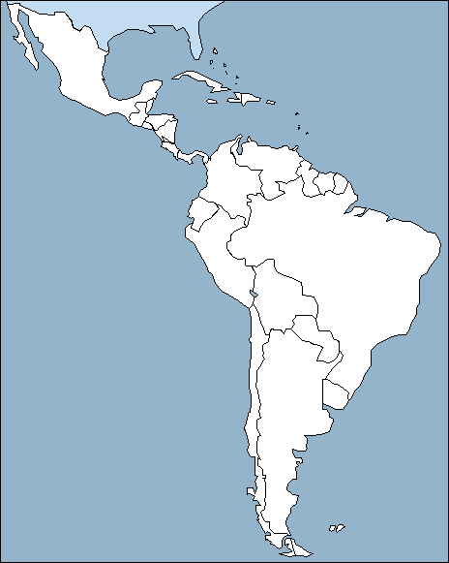

Mapping the Aztec Civilization
- Using the map on page 575, color/shade in approximately where the Aztec Empire was on the map below.

- On the map below, label the following:
  - Pacific Ocean
  - Atlantic Ocean
  - Mexico
  - United States
  - Yucatan Peninsula
  - Gulf of Mexico
  - Lake Texcoco

- Give the absolute location of Lake Texcoco: ___________________________________________________________________________
- Give the relative location of the Valley of Mexico: ___________________________________________________________________________
- What modern day country or countries would you find the Aztec civilization in? ___________________________________________________________________________
Mapping the Inca Civilization
- Using the map on page 577, color/shade in approximately where the Inca Empire was.

- Label the following:
  - Pacific Ocean
  - Atlantic Ocean
  - Mexico
  - United States
  - Yucatan Peninsula
  - Gulf of Mexico
  - Lake Titicaca
  - Amazon River

- Give the absolute location of Lake Titicaca: ___________________________________________________________________________
- List the modern day country or countries that you would find this civilization in : ___________________________________________________________________________
- Give the relative location of Machu Picchu:
___________________________________________________________________________

